**Expression**

The focus is the evaluation of the ability to communicate musically and lyrically. Strengthened by meaningful delivery of lyrics, musical diction, artistic phrasing, dynamics, energy, characterization and projection of sincere emotion. 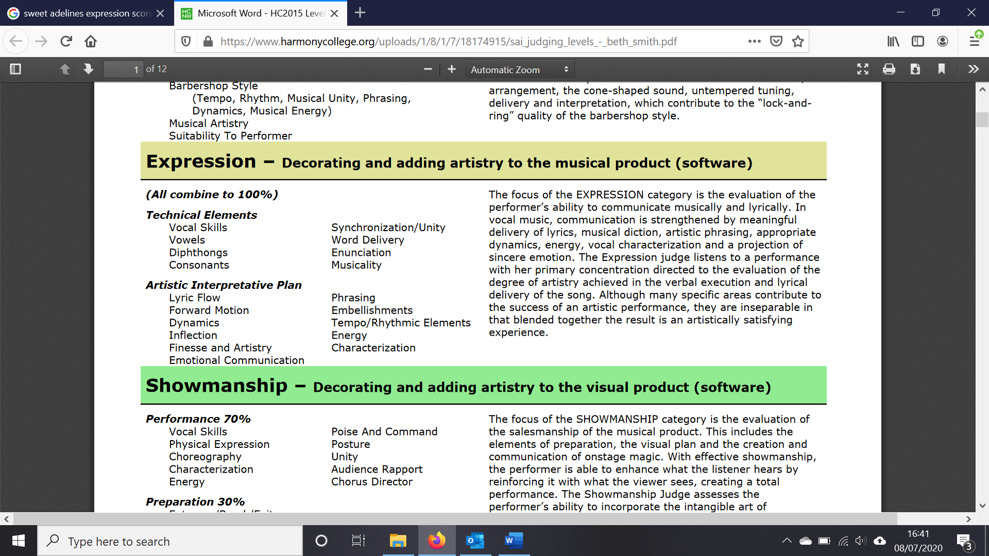

|  |  |
| --- | --- |
| **C+** | **B-** |
| Vocal skills need further development  Vowels not aligned  Interpretive plan evident but not unified (affected by sync issues)  Technical thinking evident and affecting involvement.  Artistry impacted by lack of support  Audience hmm… | Decent vocal skills  Good interpretive plan, problems with sync are still frequent.  Vowel matching not sustained  Artistry and emotional involvement overshadowed by technique.  Audience 😊 |
| **B+** | **A-** |
| Strong vocal skills  Sync issues rare  Artistry and finesse frequently evident over the technique  Genuine involvement and commitment  Audience hears the plan and enjoys the message | Technically very good  Vowels consistently matched  Strong interpretive plan rarely affected  Full involvement in character and message  A ‘singer-driven’ performance |
| **A+** |  |
| Flawless  A giant quartet  Mastery of vocal skills  Masterful interpretive plan – flawless  Excellent style and vocal drama  Strong emotional communication  Audience swept away | Are they perfect?  Where are the distractions? |