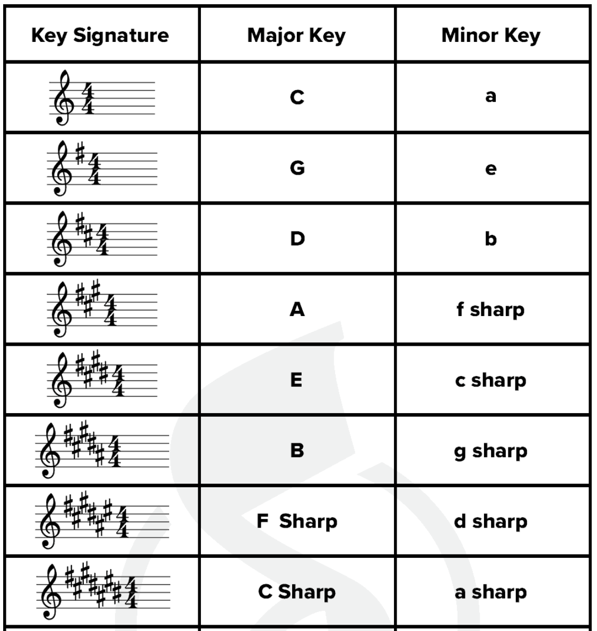

Order of sharps: Five Cats Go Down Alleys Eating Birds

Relative minor key is 3 half steps (3 semi-tones) down from the major key

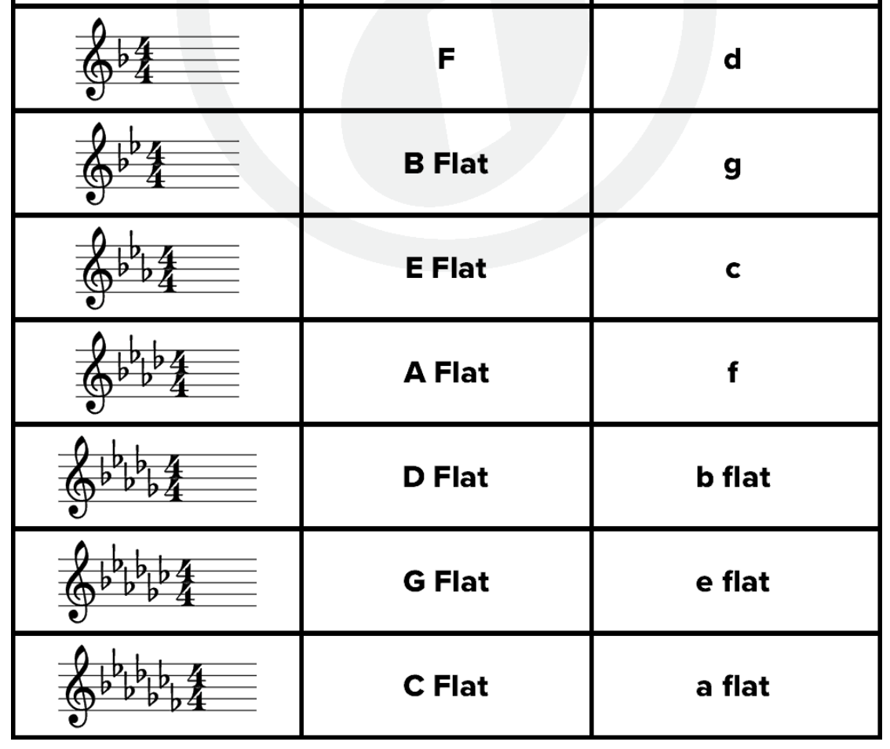

Order of Flats: BEADs – Give Color Fast

Relative minor key is 3 half steps (3 semi-tones) down from the major key

